Name: Adrian Sibayan
Course/Section: BSIT-WMT 2-2

Week 3 - Asynchronous - Lesson1-Part1 with Hands-on Exercise

Screenshot proof (Output):
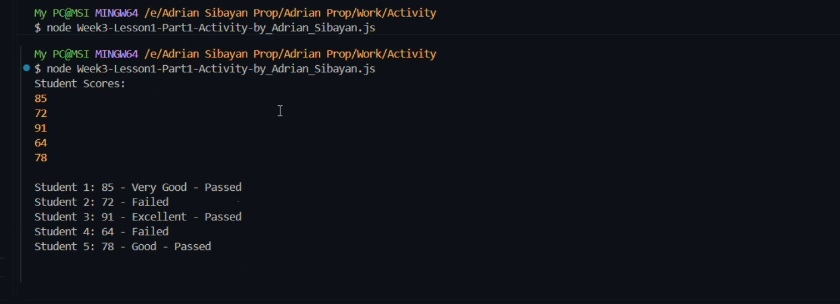
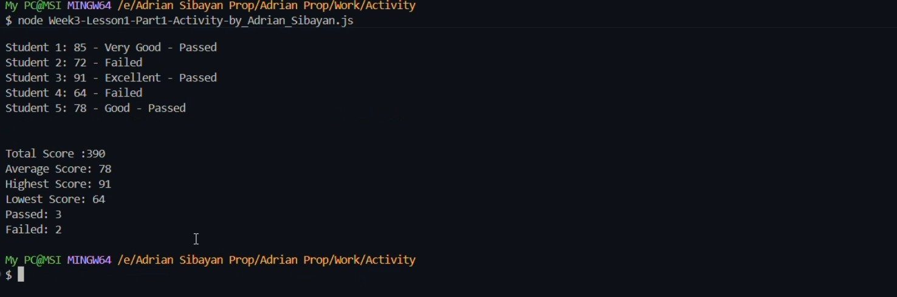
YouTube link:
https://youtu.be/wjhf0prn_gA?si=4PMv6w9KyXb86wse

